The Show

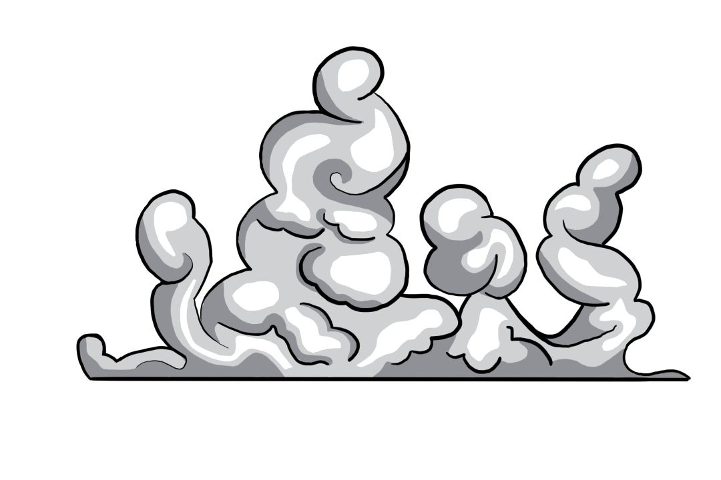

Name: ___________________

Year: ____________________

**Using the adjectives in the story, write a paragraph so that they make sense in your story.**

Today is a field trip for the students of Outspoken High and it is something quite interesting indeed, it is a  from Mrs Smith and none of the students know where they are headed to, although, Mrs Smith did contact their parents for safety measures.

Asuka is extremely excited, she used to go on field trips a lot back at her old school, and this is her  outing with her new friends from Outspoken. “Woah Asuka! 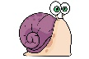 down! I cannot keep up with you!”, shouts Iris in an enthusiastic tone.

“Students! Listen up please! I need everyone to form a single  and enter the  in an orderly fashion. Please fill up the s from the front rows!” says Mrs Smith in a stern voice. The students board the  swiftly and they are ready to embark on their exciting adventure.

They stop at a massive theatre, where the kids ily jump off. Everyone finds their s and sits down quietly, waiting for the show to start, what could it be? A loud  fills the theatre and arises from the floor of the stage, as the  of grey dissipates, a shadowy figure is standing next to a box. “Welcome to Mr Houdini’s magic show! Today your s will definitely be knocked off!” Mr Houdini’s voice booms around the theatre.

In the first trick, Mr Houdini pulls out a  from his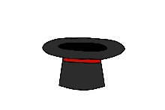. The students are quite amazed and Mrs Smith smiles, knowing how much fun the children will have. Mr Houdini makes a few marvellous tricks that stun the children, but his big act had them astonished. He had begun to levitate in the, with no strings at all! “That is super awesome! I can do that too!”, brags Jeremy. The students  at Jeremy’s crazy remarks; they had such a magnificent day. Everyone thanks Mrs Smith and climbs back into the  and they sit down, ready to go back to school.